The College of Dental Surgeons of Hong Kong | 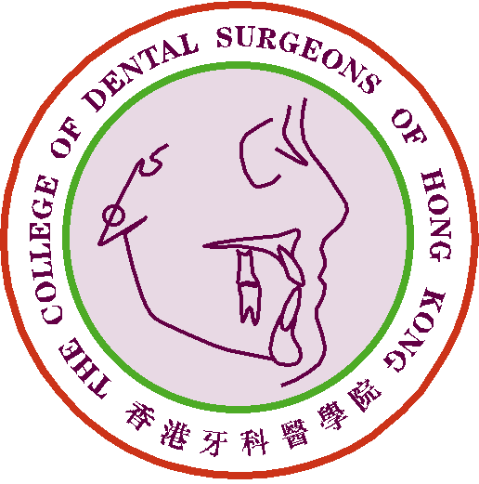

Claim Form for CME/CPD Programme

Personal Data |  | Date of Submission :
Name of Applicant : |  | Phone No.:
Email address: |  | DCHK No.:

Please ☑ one only:
1) Fellow or Specialist |  |  | 2) MGD Holder |  |  | 3) Specialist Trainee

Development or Renewal of Course Materials in eHKAM LMS
□ New Development □ Renewal
Name of Course:
Evaluation method:
Number of sessions
(hours per each session):
Total number of hours
Please submit: Confirmation Letter / Certificate of Appreciation * for
developing of Course Materials in eHKAM LMS *(Please delete as appropriate)
No. of CME point(s) claimed:

For Official Use Only | Points Awarded:
For Official Use Only | Total | CME point(s)

- The CME Subcommittee has the rights to evaluate, approve, review and revise the CME point(s) for the above activity/activities.
- Please send this form and other supporting documents by e-mail: cme_cpd@cdshk.org to College for processing.

